“Competition” Aftermarket Vehicle Security Systems

22 September 2021

* [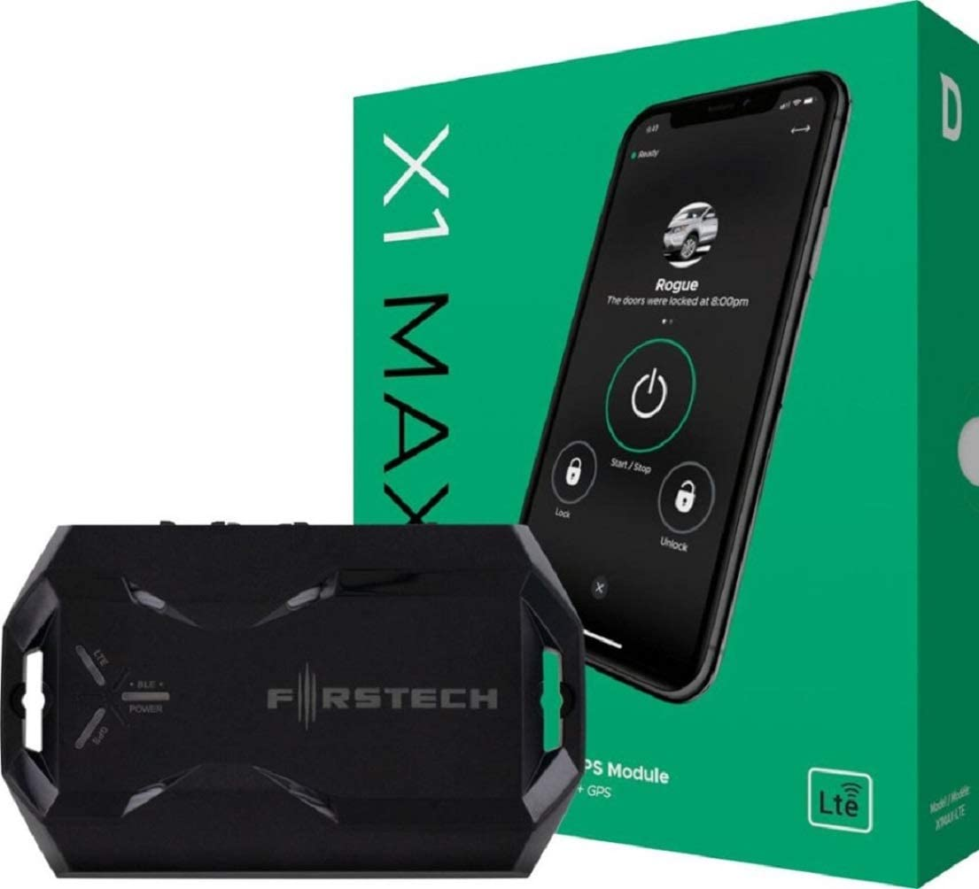N](https://www.amazon.com/dp/B081NVB8GG)ame: Firstech Compustar Drone Mobile X1MAX-LTE Telematics GPS Alarm Module Tilt Drone X1-MAX
* Purchase link: [amazon/B081NVB8GG](https://www.amazon.com/dp/B081NVB8GG)
* Description: this security system works with your car’s existing alarm system and sends a message to your phone. You can also track your car’s location if it is being stolen, and reports overall vehicle health.
* How it is similar to our security system:
  + Both systems have smartphone integration built-in.
* How it differs from our security system:
  + One of our system’s main focuses is the detection of accidental door dings (defined as another car’s door hitting your door while parked), intentional key scratches, and the theft of individual car parts (such as the catalytic converter or wheels). This system does not detect any of this.
  + This device requires a subscription to operate, while our system will be free of charge to use (Internet connection not included).
  + This device does not record what is happening with your car.
  + This device is not compatible with some cars, while our device will be compatible with virtually all vehicles.
  + This device requires professional installation, while our system will be simple for the user to install correctly.
  + This system does not use an actual audible alarm, relying on communication with your car’s existing alarm or an external alarm. Our system has an actual alarm.
  + Our system does not track a car’s location.
* 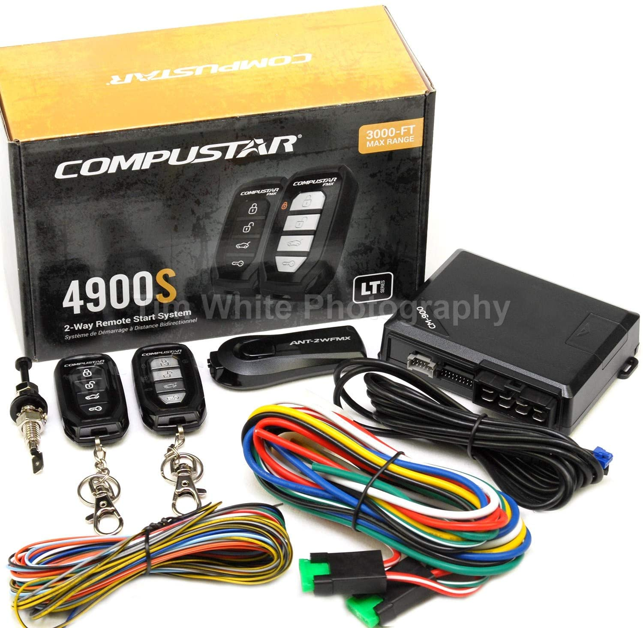Name: Compustar CS4900-S (4900S) 2-way Remote Start and Keyless Entry System with 3000-ft Range
* Purchase link: [amazon/B077MZC8RJ](https://www.amazon.com/dp/B077MZC8RJ)
* Description: a different type of security system. This system has a loud alarm that triggers if someone is breaking into your car. It also allows you to open your car doors and trunk and start your engine remotely without your keys up to a 3000 ft range.
* How it is similar to our security system:
  + Both systems are relatively easy to install (no professional installation required), which saves money.
  + Both systems have integrated alarms.
* How it differs from our security system:
  + One of our system’s main focuses is the detection of accidental door dings (defined as another car’s door hitting your door while parked), intentional key scratches, and the theft of individual car parts (such as the catalytic converter or wheels). This system does not detect any of this.
  + We are not focusing on being able to open doors or start the engine remotely.
  + Our system has smartphone integration (allowing a theoretically infinite distance between you and the car, as long as both are connected to the Internet), while this system only supports communication up to 3000 ft.
  + Our system records the crime scene while this system does not.
* 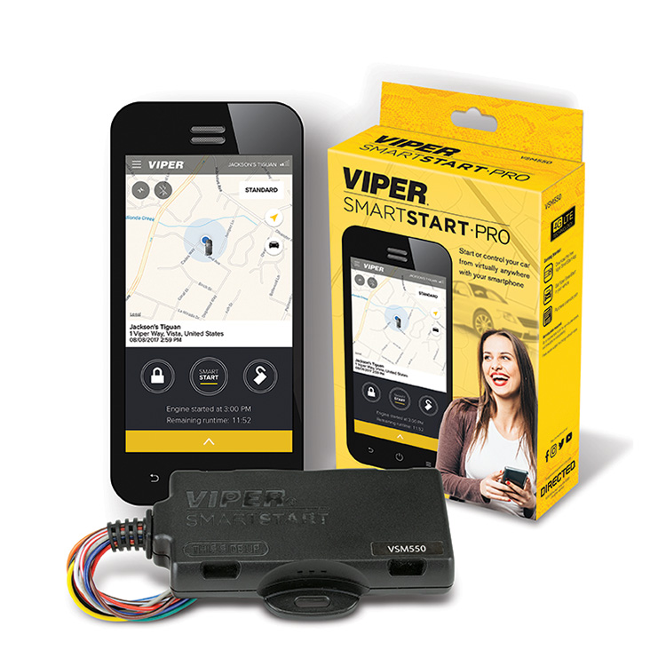Name: Viper SmartStart
* Purchase link: [Viper SmartStart](https://www.viper.com/smartstart/)
* Description: the Viper SmartStart system is a combination of the above two security systems: it allows you to start your engine and lock/unlock your car doors and trunk from your phone while also giving the GPS location of your car if it is being stolen.
* How it is similar to our security system:
  + Both have built-in smartphone integration by design.
* How it differs from our security system:
  + One of our system’s main focuses is the detection of accidental door dings (defined as another car’s door hitting your door while parked), intentional key scratches, and the theft of individual car parts (such as the catalytic converter or wheels). This system does not detect any of this.
  + The system does not record video as evidence, while our system does.
  + Our system is not focused on the ability to open doors, start engines, or track the cars via GPS.
  + This system requires professional installation, while our design will allow for easy and correct DIY installation by the user.
  + This system requires a paid subscription, while our system is free of charge (Internet not included).
  + This system may not work with all (older) cars or transmission types (i.e. manual transmissions). Our system is designed to work with virtually any car.